The article title

Ivanov A.A.1, Petrov A.B.*,2, Sidorov B.C.3 **The speaker's name must be underlined**

1 Institute for Automation and Control Processes, 5 Radio St., Vladivostok 690041, Russia

2 Institute of Semiconductor Physics of SB RAS, 13 pr. Lavrentieva, Novosibirsk 630090, Russia

3 Far Eastern Federal University, 8 Sukhanova St., Vladivostok 690950, Russia

*e-mail: corresponding_autor_mail@gmail.com

**Abstract.** **Place here the abstract of your article. It must be no more than 150 word**. Abstract text Abstract text Abstract text Abstract text Abstract text Abstract text Abstract text Abstract text Abstract text Abstract text Abstract text Abstract text Abstract text Abstract text Abstract text Abstract text Abstract text Abstract text Abstract text Abstract text Abstract text Abstract text Abstract text Abstract text Abstract text Abstract text Abstract text Abstract text Abstract text Abstract text Abstract text Abstract text Abstract text Abstract text Abstract text Abstract text Abstract text Abstract text Abstract text Abstract text Abstract text Abstract text.

1. Introduction

For preparing your article please use this template and the text format styles defined here. You can type a text in each section or you can copy and paste a text but doing so use the paste option that format your text like surrounding text. If you use MS Office 97 – 2003, then any mathematical equations in the article must be typed using **Microsoft Equation 3.0** object. If you MS Office 2007‑2016 user, then use standard INSERT 🡪 EQUATION option. If you use symbols like α, β, Δ, or ×, please, use standard symbol insert option. All the tables and figures should have width no more than 8.3 cm so that they could be placed inside one column. Figures should be placed in text and aligned by center or you can simply apply ASCO-NANOMAT_Figure style on them. It is highly recommended that you use **TIFF** format for gray scale images and **PNG** for graphs. The resolution must be no less than **300 dpi**. Article references in the text should be placed in brackets like this **[1].**

**Your article must consist of no more than 2 pages.**

2. Experiment

Body text Body text Body text Body text Body text Body text Body text Body text Body text Body text Body text Body text Body text Body text Body text Body text Body text Body text Body text Body text Body text Body text Body text Body text Body text Body text Body text Body text Body text Body text Body text Body text Body text Body text Body text Body text Body text Body text Body text Body text Body text Body text Body text Body text Body text Body text Body text Body text Body text Body text Body text Body text Body text Body text Body text Body text Body text Body text Body text Body text Body text Body text Body text Body text Body text Body text Body text Body text Body text Body text Body text Body text Body text Body text Body text Body text Body text Body text Body text Body text Body text Body text Body text Body text Body text Body text Body text Body text Body text Body text Body text Body text Body text Body text Body text Body text Body text Body text Body text Body text Body text Body text Body text Body text Body text Body text Body text Body text Body text Body text Body text Body text Body text Body text Body text Body text Body text Body text Body text Body text Body text Body text Body text Body text Body text Body text Body text Body text Body text Body text Body text Body text Body text Body text Body text Body text Body text Body text Body text Body text Body text Body text Body text Body text Body text Body text Body text Body text Body text Body text Body text Body text Body text Body text Body text Body text Body text Body text Body text Body text

**Table I.** Parameters of Samples

|  |  |  |  |  |
| --- | --- | --- | --- | --- |
| Sample | Substrate | Implanted dose, (cm-2) | Conduc-tivity type | Resistivity, (Ohm cm) |
| *A* | Si(111) | 1016 | *p* | 20 |
| *B* | Si(111) | 1.8×1017 | *p* | 20 |
| *C* | Si(100) | 1015 | *n* | 4.5 |
| *D* | Si(100) | 1016 | *n* | 4.5 |
| *E* | Si(100) | 1.8×1017 | *n* | 4.5 |

3. Results and discussions

Body text Body text Body text Body text Body text Body text Body text Body text Body text Body text Body text Body text Body text Body text Body text Body text Body text Body text Body text Body text Body text Body text Body text Body text Body text Body text Body text Body text Body text Body text Body text Body text Body text Body text Body text Body text Body text Body text Body text Body text Body text Body text Body text Body text Body text Body text Body text Body text Body text Body text Body text Body text Body text Body text Body text Body text Body text Body text Body text Body text Body text Body text Body text Body text Body text Body



Body text Body text Body text Body text Body text Body text Body text Body text Body text Body text Body text Body text Body text Body text Body text Body text Body text Body text Body text Body text Body text Body text Body text Body text Body text Body text Body text Body text Body text Body text Body text Body text Body text Body text Body text Body text Body text Body text Body text Body text Body text Body text Body text Body text Body text Body text Body text Body text Body text Body text Body text Body text Body text Body text Body text Body text Body text Body text Body text Body text Body text Body text Body text Body text Body text Body text Body text Body text Body text Body text Body text Body text Body text Body text Body text Body text Body text Body text Body text Body text Body text Body text Body text Body text Body text Body text Body text Body text Body text Body text Body text Body text Body text Body text Body text Body text Body text Body text Body text Body text Body text Body text Body text Body text Body text Body text Body text Body text Body text Body text Body text Body text Body text Body text Body text Body text Body text Body text Body text Body text Body text Body text Body text Body text Body text Body text Body text Body text Body text Body text Body text Body text Body text Body text Body text Body text Body text Body text Body text Body text Body text

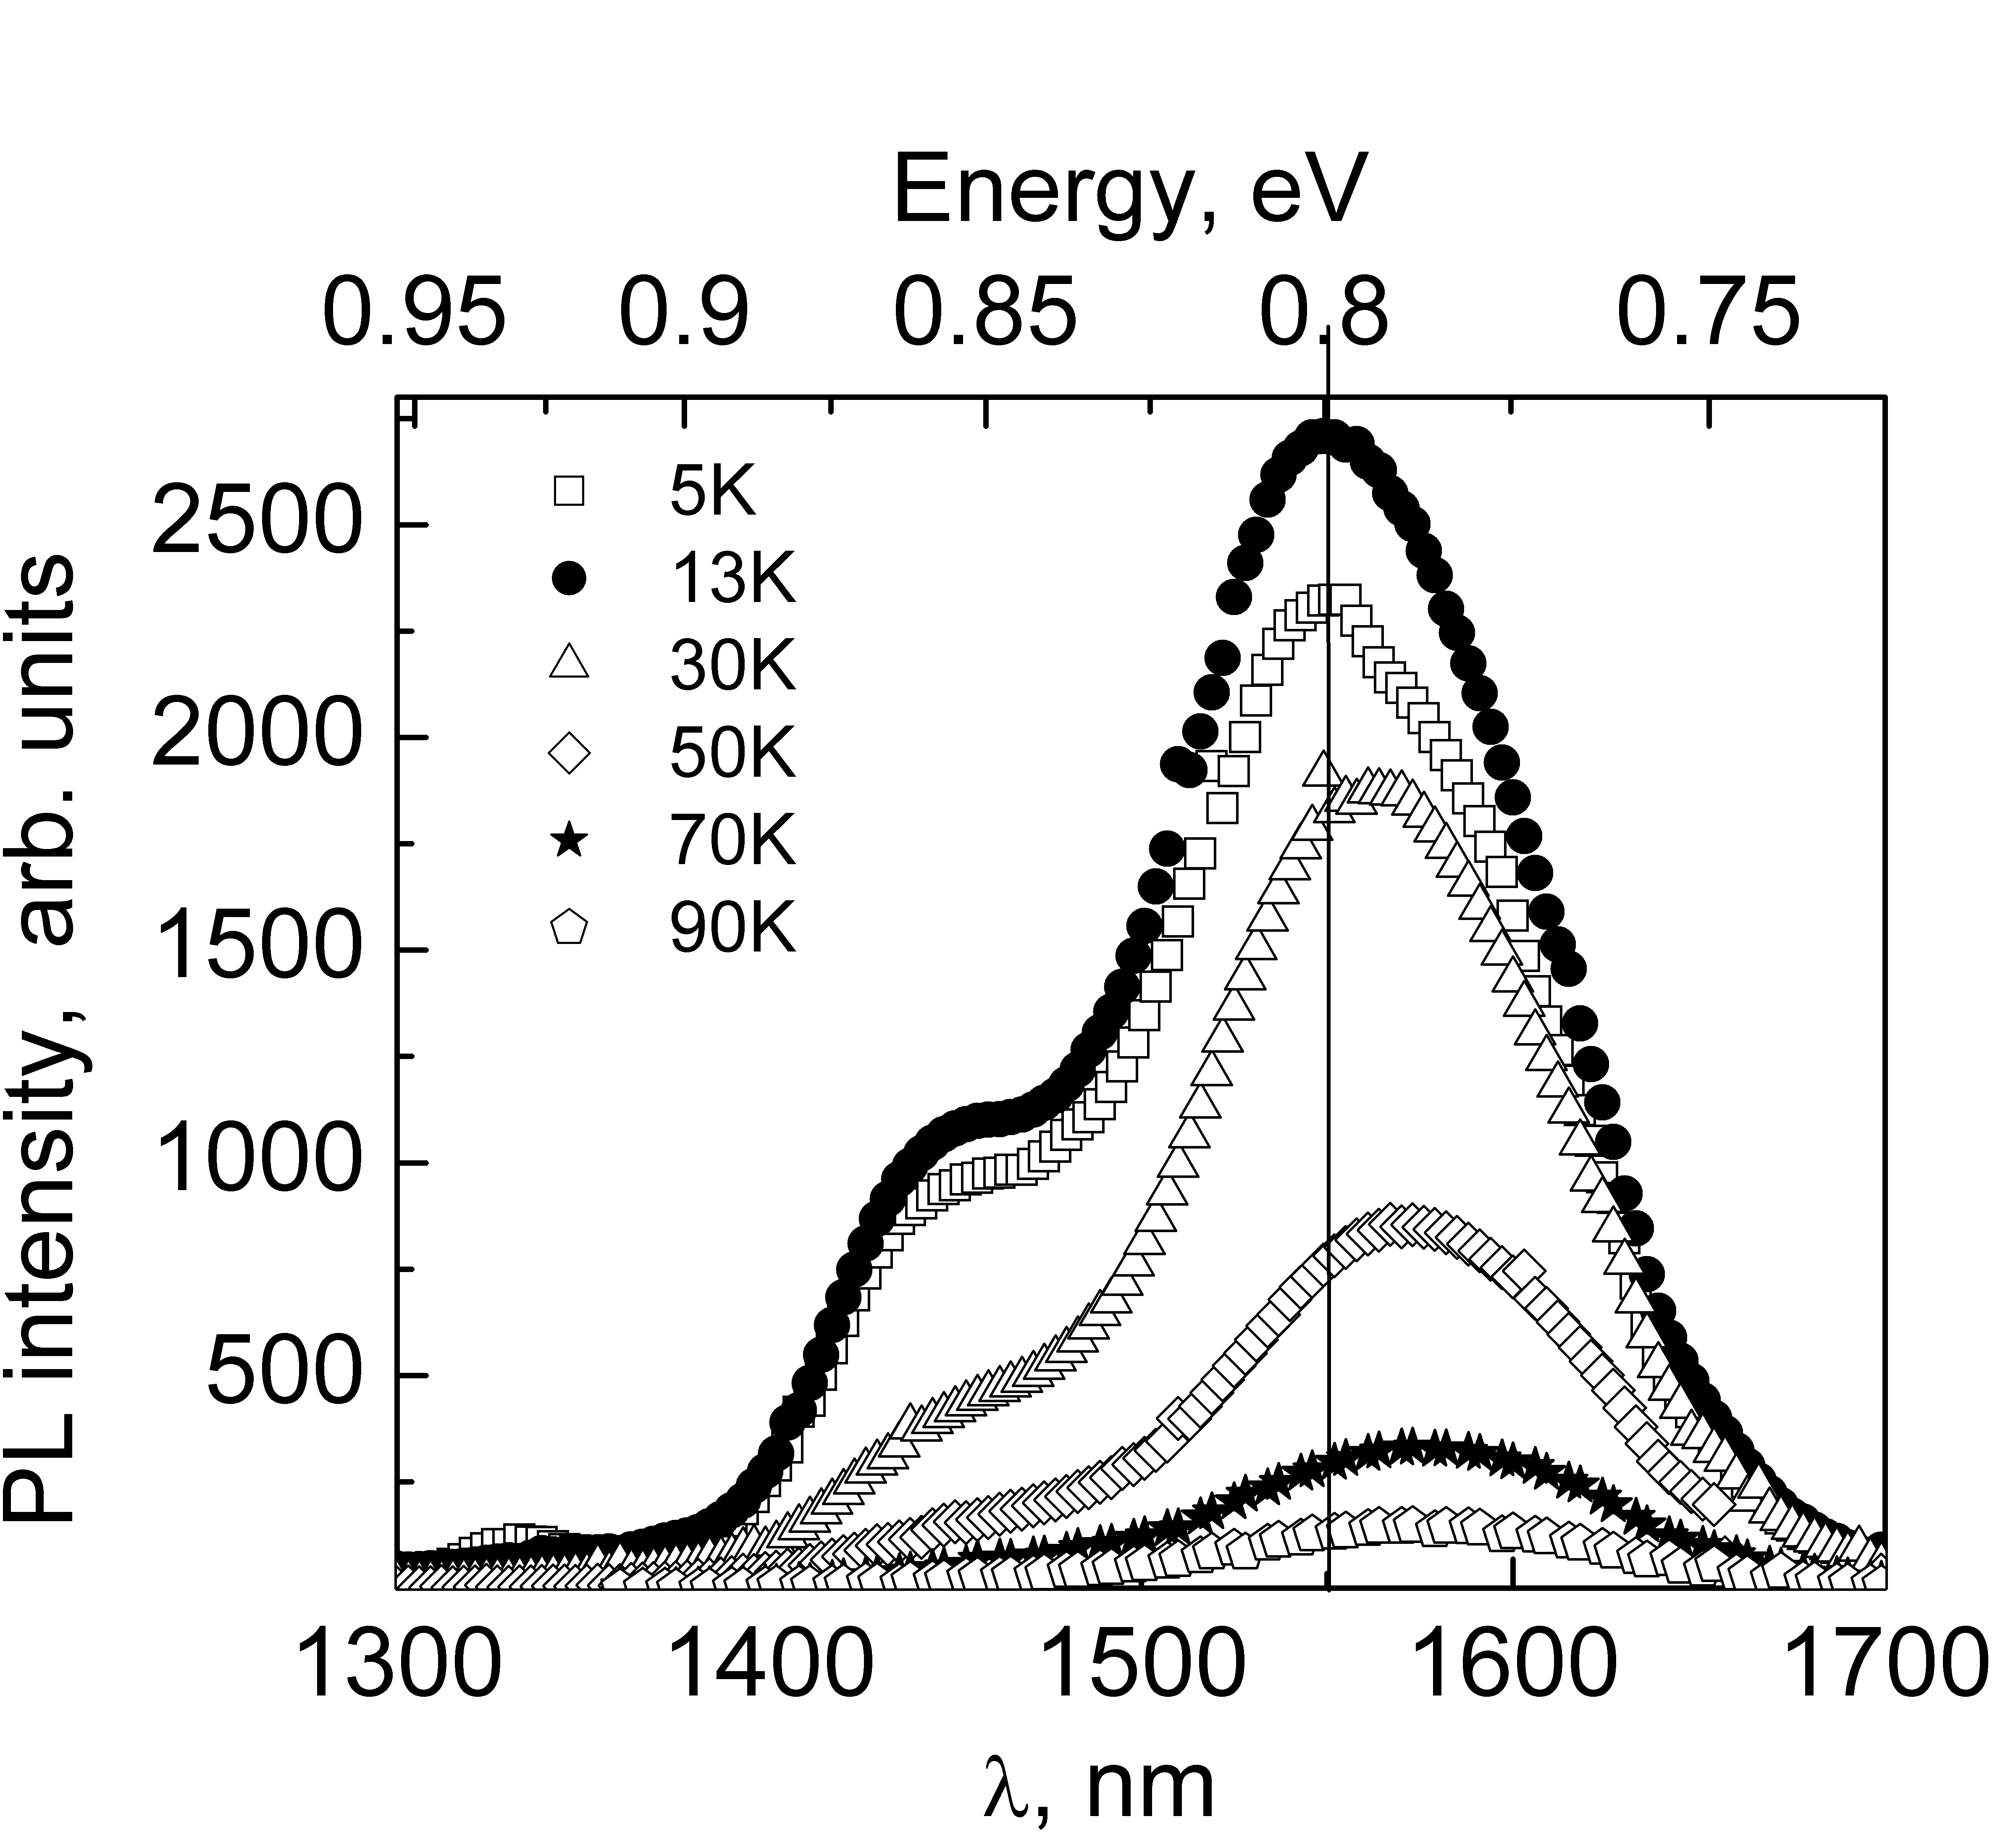

**Fig. 1.**Photoluminescence spectra of sample D. There is a red shift of the peak position with increasing of temperature.

Body text Body text Body text Body text Body text Body text Body text Body text Body text Body text Body text Body text Body text Body text Body text Body text Body text Body text Body text Body text Body text Body text Body text Body text Body text Body text Body text Body text Body text Body text Body text Body text Body text Body text Body text Body text Body text Body text Body text Body text Body text Body text Body text Body text Body text Body text Body text Body text Body text Body text Body text Body text Body text Body text Body text Body text Body text Body text Body text Body text Body text Body text Body text Body text Body text Body text Body text Body text Body text Body text Body text Body text Body text Body text Body text Body text Body text Body text Body text Body text Body text Body textBody text Body text Body text Body text Body text Body text Body text Body text Body text Body text Body text Body text Body text Body text Body text Body text Body text Body text Body text Body text Body text Body text Body text Body text Body text Body text Body text Body text Body text Body text Body text Body text Body text Body text Body text Body text Body text Body text Body text Body text Body text Body text Body text Body text Body text Body text Body text Body text Body text Body text Body text Body text Body text Body text Body text Body text Body text Body text Body text Body text Body text Body text Body text Body text Body text Body text Body text Body text Body text Body text

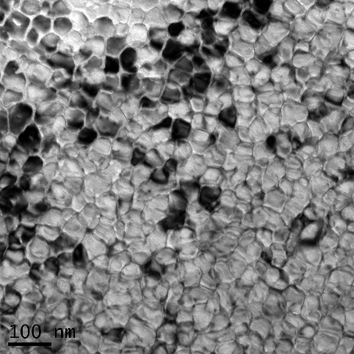

**Fig. 2.** Bright-field TEM image of the Cr-implanted Si layer (Φ = 3×1016 cm-2) after PLA (W = 1.6 J/cm2).

Body text Body text Body text Body text Body text Body text Body text Body text Body text Body text Body text Body text Body text Body text Body text Body text Body text Body text Body text Body text Body text Body text Body text Body text Body text Body text Body text Body text Body text Body text Body text

4. Conclusions

Body text Body textBody text Body text Body text Body text Body text Body text Body text Body text Body text Body text Body text Body text Body text Body text Body text Body text Body text Body text Body text Body text Body text Body text Body text Body text Body text Body text Body text Body text Body text Body text Body text Body text Body text Body text Body text Body text Body text Body text Body text Body text Body text Body text Body text

Acknowledgements

**Place your acknowledgements here**

References

1. K. Oyoshi, D. Lenssen, R. Carrius, S. Mantl. Thin Solid Films **381**(2001)194.
2. T. Suemasu, T. Fujii, K. Takakura, F. Hasegawa. Thin Solid Films **381**(2001)209.
3. R. Bayazitov, R. Batalov, R. Nurutdinov, V. Shustov, P. Gaiduk, I. Dezsi, E. Kotai. Nucl. Instr. Meth. **B 24**(2005)224.
4. K. Oyoshi, D. Lenssen, R. Carius, S. Mantl. Thin Solid Films **381**(2001)202
5. J. Chrost, J. J. Hinarejos, E. G. Michel, R. Miranda. Surf. Sci. **330**(1995)34.